BlueCube to ESO

Data Extraction and Loading

# Overview

This document describes the processes and user integration that are required in order to extract data from the Speedway specific version of Bluecube Enterprise and import the data into the latest version of JDA Enterprise Site Operations.

# Datasets to Extract and Load

The following data sets will be extracted and loaded. Note: as of 8/7 the filtering is not final and is subject to further review.



# Process Flow

There are two types of extraction and loading:

* Direct mode where the data is extracted, transformed, and imported into ESO.
* Review mode where someone will verify and cleanse the data before submitting it to be imported.

## Direct Mode

Process for Direct Mode, no user review.

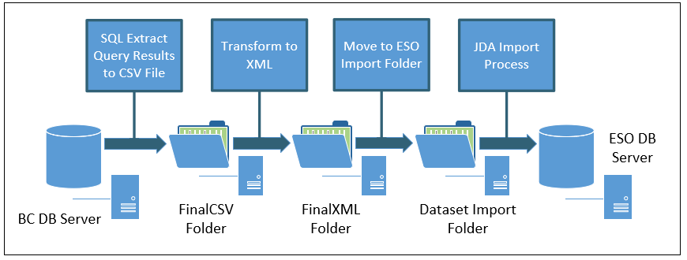

### Direct mode uses 3 folders and 4 processes

FinalCSV – A SQLCmd program will process a query and generate a comma delimited file. Because there is no review step, the extracted CSV is considered final.

FinalXML – A Jscript program and an XSL Transform will take final CSV files and convert the data into and XML file that matches the JDA ESO schema.

Dataset Import Folder – This is the standard JDA ESO folder that has directories for the client and each supported dataset. Files will be moved from FinalXML into the import folder either manually or via a command line script.

## Review Mode

Process Flow for Review Mode

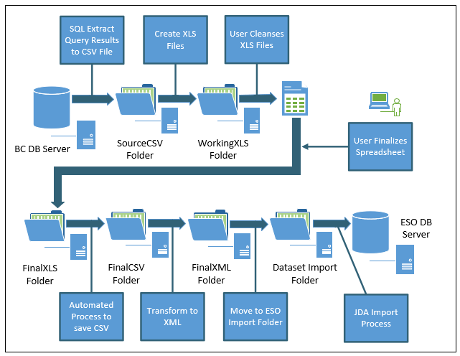

Review mode uses 6 folders and 7 processes

SourceCSV – A SQLCmd program will process a query and generate a comma delimited file. Because there is a review step, the extracted CSV is not considered final.

WorkingXLS – A Jscript program will convert the source CSV to an XLS file and place it in a working directory. In this directory the user can edit and save changes until the spreadsheet is finalized.

FinalXLS – Once the spreadsheet is final, the user must save it to a final folder.

FinalCSV – A Jscript program will convert the final XLS into a CSV and place it in the Final CSV folder.

FinalXML – A Jscript program and an XSL Transform will take final CSV files and convert the data into and XML file that matches the JDA ESO schema.

Dataset Import Folder – This is the standard JDA ESO folder that has directories for the client and each supported dataset. Files will be moved from FinalXML into the import folder, either manually or via a command line script.

# Review Spreadsheets

## Special Characters

Due to limitations and challenges with CSV files and Excel, special characters are used as place holders:

### The underbar “_”

This character is used in front of a value that can be a number and have leading zeros. For example, a Business Unit Code of 009455 would be shown as _009455. These underbars should be ignored and left alone. If a value is entered into a column that uses this technique (i.e., adding a new Barcode) the underbar must be entered by the user.

### The tilde “~”

Tildes are placeholders for commas within the actual data. For example - Enon, OH would be represented as Enon~OH. The tilde will be converted back into a comma during the transformation to XML. Technically tildes can be added or removed but should generally be left alone except to correct an error.

### The pipe “|”

Pipes are placeholders for single quote/apostrophes. For example – Mike’s Bakery would be represented as Mike|s bakery. The pipe will be converted back into an apostrophe during the transformation to XML. This character will only show in the category name of the item import spreadsheets.

### Asterisk “*”

If an asterisk appears in a column heading it generally means that the value is required for the first row of the Item, Retail Pack, or Supplier Item. There are more details described in each section, but a good rule of thumb is that if a column with an asterisk in the header already has a value, it should be retained or changed to another valid value, but not cleared out.

## Item

The Item spreadsheet allows a user to review the list of Items that have been extracted from the BC data. The extract process will create files per department with some of the larger departments segmented into smaller files.

The spreadsheet template is hierarchical with 5 groups of rows

### Item ExternalID Key

Column A is the Item External ID. It must always have a value. The value is used to indicate rows that are related to the same Item. To remove an Item from the spreadsheet, all of the rows for the External Id must be deleted or an import error may occur.

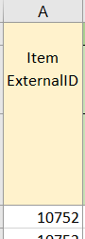

### Common Item Properties

Common Items properties are those fields that are common for all Items even the Items that are not sold or tracked. When the row is blank it indicates that there are additional values to the right of the common properties.

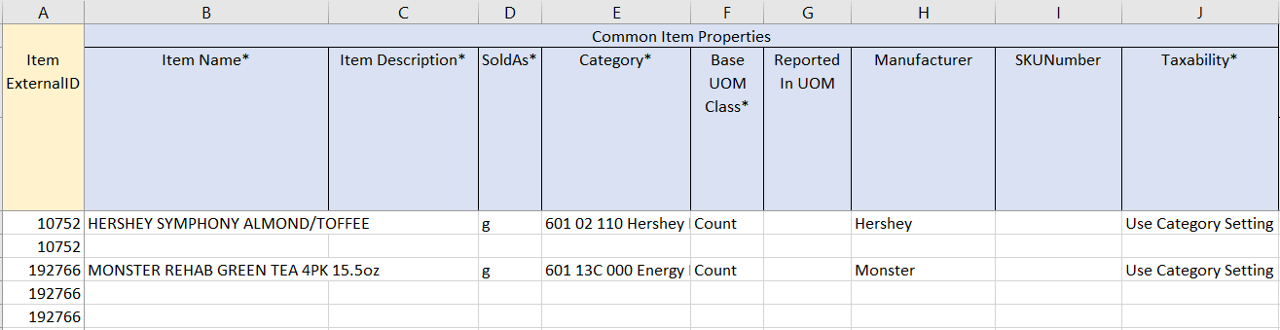

**Notes:**

The sold as flag is there for reference and should not be changed.

The Category should already exist before this spreadsheet can be saved to the final XLS folder.

Base UOM can only be Count, Weight, or Volume.

Taxability can only be, Use Category Setting, Taxable, and Non-taxable.

### Tracking

If an Item is configured for inventory, the values will be imported into the tracking section.

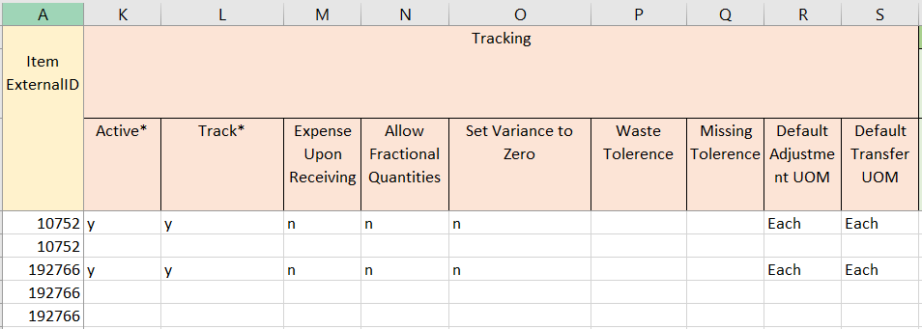

**Notes:**

Unless these values are incorrect, the values should be left alone. If an Item needs to be marked inactive, it is probably better to remove the Item altogether.

### Selling – Base Properties

The base properties for Items that are sold are in a separate section. There will be a single separate spreadsheet for the Items that are not sold, so nearly all of the spreadsheets will have selling properties set.

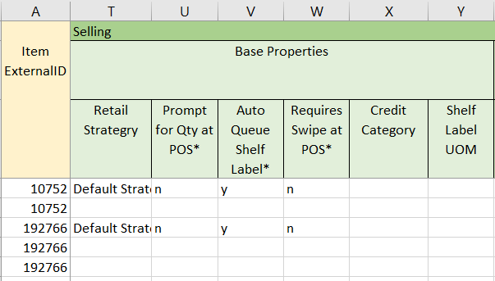

**Notes:**

Unless a value is incorrect, the value should be left alone. If a retail strategy change is needed, the ramifications to Price Event import need to be considered in order to prevent the loss of existing retail prices.

### Selling – Retail Packs

A sellable Item must have at least one retail pack.

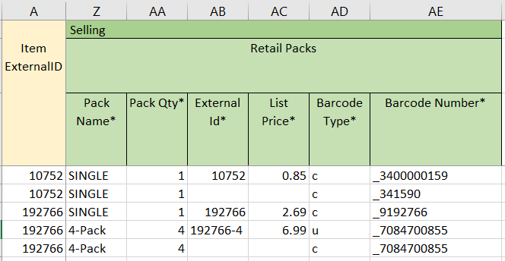

**Notes:**

The Pack Name and Pack Qty must always have a value.

If the value of the List Price column is not empty, the row must have a value for the External Id for the Retail Pack. The source data will set this value and it should not be altered.

There is only one List Price allowed for the Retail Pack.

Barcodes are listed for each pack, they can be removed or added to.

If Barcode Number is present it should have a Type (c, e, g, u). UPC (u) and Custom (c) should be the most frequently used.

At a minimum a Barcode line must have the Pack Name and Pack Qty. The other values can be left blank.

If a Pack Name and Pack Qty are duplicated due to multiple Barcodes, the rows must still be grouped together.

## Supplier Item/Catalog

The Supplier Item spreadsheet allows a user to review the list of Supplier Items that have been extracted from the BC data. The extract process will create files per supplier with some of the larger suppliers segmented into smaller files.

The spreadsheet template is hierarchical with 5 groups of rows

### Supplier Identification

The Name and Xref of the Supplier will be at the top of the Spreadsheets. These values are for information only and should not be altered or an import error may occur.

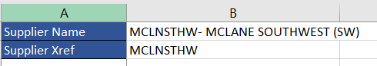

### Product Code Key

Column A is the Supplier Item Product Code. It must always have a value. The value is used to indicate rows that are related to the same Supplier Item. To remove a Supplier Item from the spreadsheet, all of the rows for the Product Code must be deleted or an import error may occur.

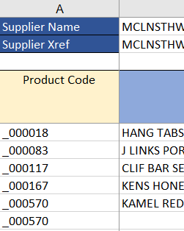

### Common Supplier Item Properties

Common properties identify the Supplier Item. When the line is blank it indicates that there is additional information in rows to the right of the common properties.

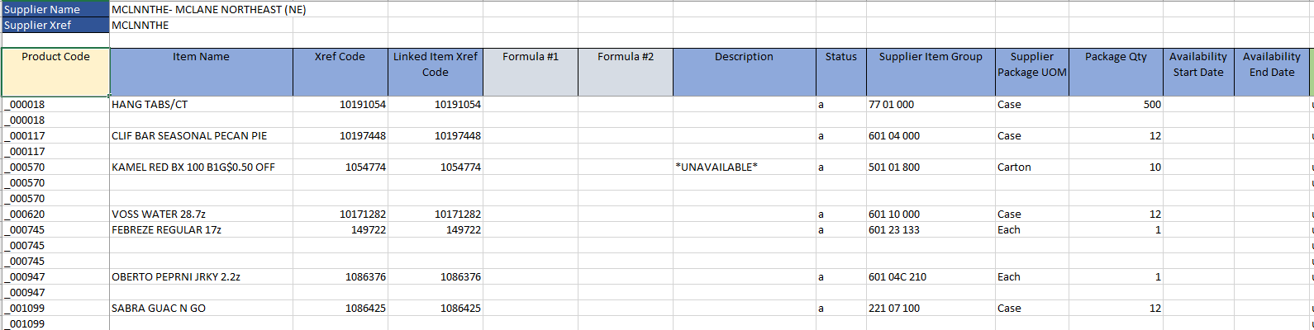

**Notes:**

All of the fields can be modified, however unless there is an error the values should generally be left alone.

Supplier Groups will be created if not already present.

Package data will be created if not already present.

There are two “Formula” columns. These columns do not represent data, but are provided to allow the usering to include helpful formulas.

### Special Handling of the Description Field

Because the catalog import process only suppuorts the supplier item status code and keeps it in synch with the packaged item status code, we populate the description field in the import with a special string to indicate the packaged item status. After the supplier item import, we change the status code based upon the name If the description contains the string “*UNAVAILABLE” or “INACTIVE”, the supplier package item status will be modified after the import based upon the description.

### Supplier Item Barcodes

A Supplier Item can have no Barcodes or multiple Barcodes. If there are multiple barcodes the Product Code line is repeated.

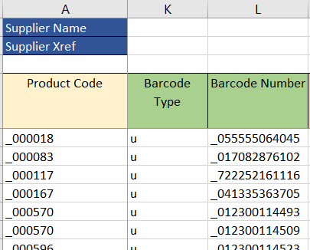

**Notes:**

Since this information is usually provided by the supplier it is unlikely that this data should be edited. If a Barcode should be removed, the best approach would be to clear the field values without removing the row. If I Barcode needs to be added, the Product Code value must be set manually.

The screen example indicates the usage of the underbar “_”. It must be preserved if any data is altered or new data is entered.

### Supplier Item Cost Levels

Each Supplier Item can have multiple Cost Levels and multiple prices for the cost level.

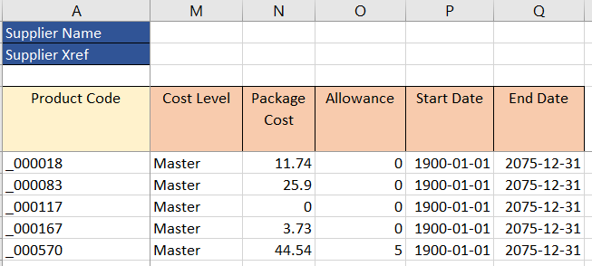

**Notes:**

This information is provided by the supplier and should generally not be edited.

The spreadsheet can not be used to add cost for an unknown Cost Level.

Adding new costs can be accomplished, however the user must pay close attention to make sure that the cost Start Date and End Dates do not overlap for the same Cost Level.

### Relationship between Barcodes and Cost Levels

It is important to understand that the Barcode and Cost Level sections are independent lists. There is no relationship between the two. The example below indicates this. Product code 056382 has multiple Barcodes and 2 Cost Levels, but there is no relationship between the two groups.

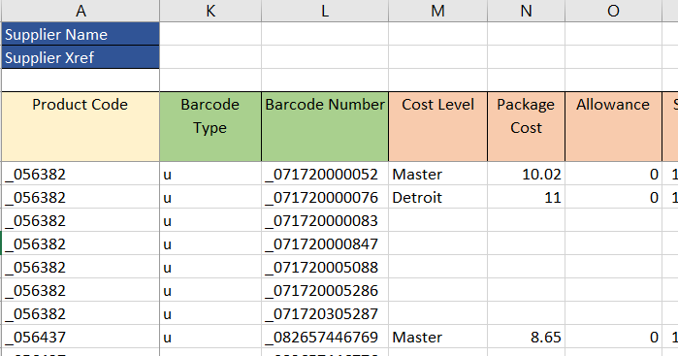

## Specials

The specials spreadsheet allows a user to review the list of specials that have been extracted from the BC data. The extract process will create one file with all specials.

The spreadsheet template is hierarchical with 2 groups of rows, one row of general information for each special and another group of rows to describe each of the qualifiers for the special.

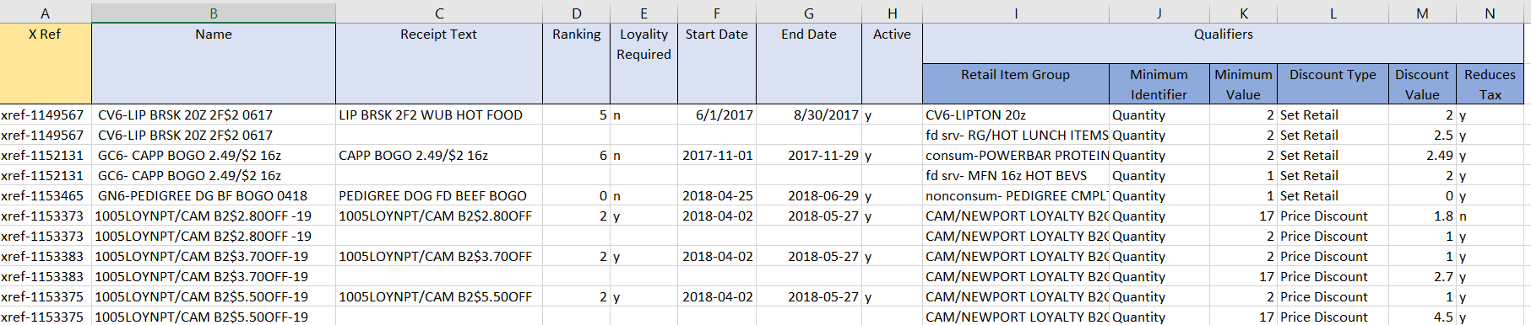

### Special ExternalID Key

Column A is the Special Xref ID. It must always have a value. The value is used to indicate rows that are related to the same Special. To remove a Special from the spreadsheet, all of the rows for the Xref Id must be deleted or an import error may occur.

